**Leland Randles DATA606**

Homework, Chapter 2

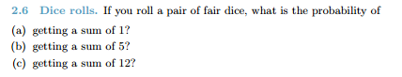

1. The probability is zero because it is not possible to roll two dice and get a sum of 1
2. There are four different combinations which could lead to a sum of 5 – 1 & 4, 2 & 3, 4 & 1, or 3 & 2, hence the probability is 4 out of the total combinations, which is 36 (6 times 6). Hence the probability is 4/36 or 1/9.
3. Only 6 and 6 would yield a sum of 12, and the odds of rolling two sixes is 1/6 * 1/6 or 1/36.

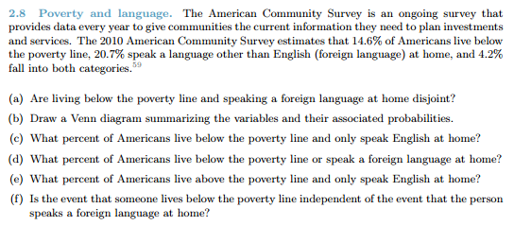

1. No, they are not disjoint
2. Oval labeled “speak foreign language” represents 20.7% of survey participants, oval with “live below poverty line” represents 14.6% of survey participants, and the intersection of the two ovals represents the 4.2% that fall into both categories:

1. 14.6% minus 4.2% = 10.4%
2. 14.6% + 20.7% - 4.2% = 31.3%
3. Seems to be repeat of c above, which was 14.6% minus 4.2% = 10.4%
4. No, there is overlap between the two

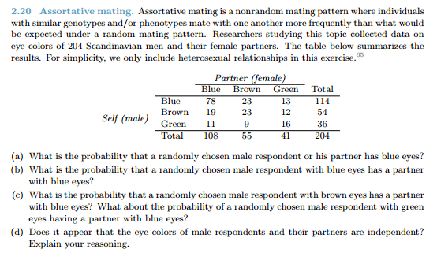

1. There are three possibilities that fulfill the question – the male has blue eyes but his partner does not, the male does not have blue eyes but his partner does, or both the male and his partner have blue eyes. 36 respondents fit the first scenario, 30 respondents fit the 2nd scenario, and 78 respondents fit the 3rd scenario, which is a total of 144 out of a total of 204 respondents, which means the probability is 144/204 = 0.706.
2. 78 / 114 = 0.684
3. 19 / 54 = 0.352; 11 / 36 = 0.306
4. No. It appears it is more likely that males will pick a partner with the same eye color over a partner with a different eye color, so when you know what color eyes the male respondent has, it effects the likelihood for the eye color of the partner.

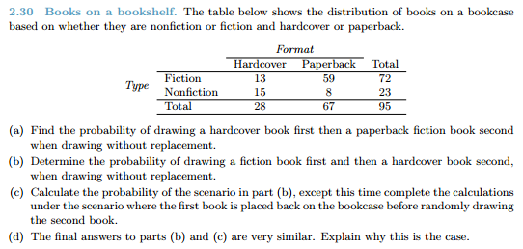

1. Probability of drawing a hardcover book is 28 / 95. Probability of drawing a paperback fiction book next without replacement is 59 / 94. Hence the probably of drawing the two in order is 28/95 * 59/94 = 0.185
2. Probability of drawing a fiction book is 72 / 95. Probability of drawing a hardcover book next without replacement depends on whether the fiction book drawn was paperback or hardcover. There was a 13/72 chance the fiction book was hardcover, and 59/72 chance that it was paperback. Therefore, the chance that the 2nd book drawn is a hardcover book is (13/72)*(27/94) + (59/72)*(28/94), which equals 0.296. Take 72/95 * 0.296 and you get 0.224.
3. 72/95 * 28/95 = 0.223.
4. There are fairly similar because the sample size is fairly large (95 books). The effect of sample with or without replacement diminishes based on the size of the sample.

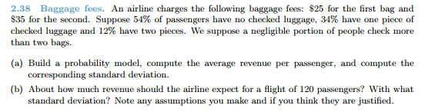

1. Expected value is 15.7. As you can see from table below, the variance is 376.12, so the standard deviation (σ) = 376.12^0.5 = 19.394.

|  |  |  |  |  |
| --- | --- | --- | --- | --- |
| ***i*** | **1** | **2** | **3** | **Total** |
| *x*i  (in dollars) | 0 | 25 | 60 |  |
| *P(X* *= xi)* | 0.54 | 0.34 | 0.12 |  |
| *x*i * *P(X* *= xi)* | 0 | 8.5 | 7.2 | 15.7 |
| *x*i - *µ* | -15.7 | 9.3 | 44.3 |  |
| (*x*i - *µ*)2 | 246.69 | 86.49 | 1962.49 |  |
| (*x*i - *µ*)2 * *P(X* *= xi)* | 133.21 | 29.41 | 235.50 | 376.12 |

1. For 120 passengers, you would expect 120 * $15.70 = $1,884. The standard deviation of this amount would also be $19.394.

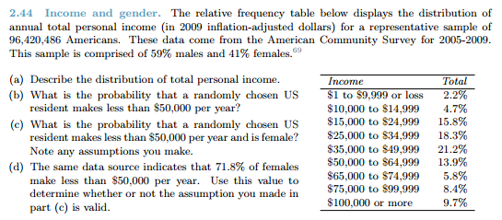

1. It is right-skewed, unimodal
2. 2.2 + 4.7 + 15.8 + 18.3 + 21.2 = 62.2%
3. If we assume salaries are equal between the genders (unlikely), then it would be the probability computed in (b) above multiplied times the probability of the resident being female (0.41). 0.622 * 0.41 = 0.255.
4. If the overall population (males and females combined) has a 62.2% chance of making less than $50K/year, and 71.8% of females make less than $50K/year, then females disproportionately make under $50K/year, and the percentage of males that make $50K/year or less is going to be significantly below 62.2%, because that is for the whole population. Given the very large sample size and big difference between males and females in the percentages of individuals making less than $50K/year, my gut instinct is that the difference would easily meet significance thresholds indicating a difference between male and female populations with respect to likelihood they make less than $50K/year. Therefore the assumption used for (c) is likely untrue.